Chapter 4 – Design and Development phase

The design stage of a project is very important once it allows the design of the User Interface (UI) and the User experience (UX) of the application <https://www.businessofapps.com/insights/stages-of-app-development/>. Within this phase, wireframes and Blueprints are created to allow developers to build the final app.

The wireframes are an UX-based view of how the application is going to work and especially how the screens will flow between them.

Still need to work here.

The proposed mobile app starts with a Splash Screen emphasizing the logo of the project. The splash screen or start screen or start up screen is defined by Techopedia (2016) as a specific screen to be displayed while the application is still loading. Once it is loaded the User will be directed to the main screen (Home Screen) and others as it follows within the next sections.

4.1 Screen 1: Home screen

When the user opens up the application, the first screen that they see is the Home Screen which consists of two linkable buttons. The first button is intended to a user that is already registered within the application (Sign in with Pawdopter), it means that the potential adopter can sign in using the app’s database. The second button, however, is for users who are not yet registered within the application, meaning that they need to Register beforehand (please, see the Wireframe of this screen on Figure 4.1).

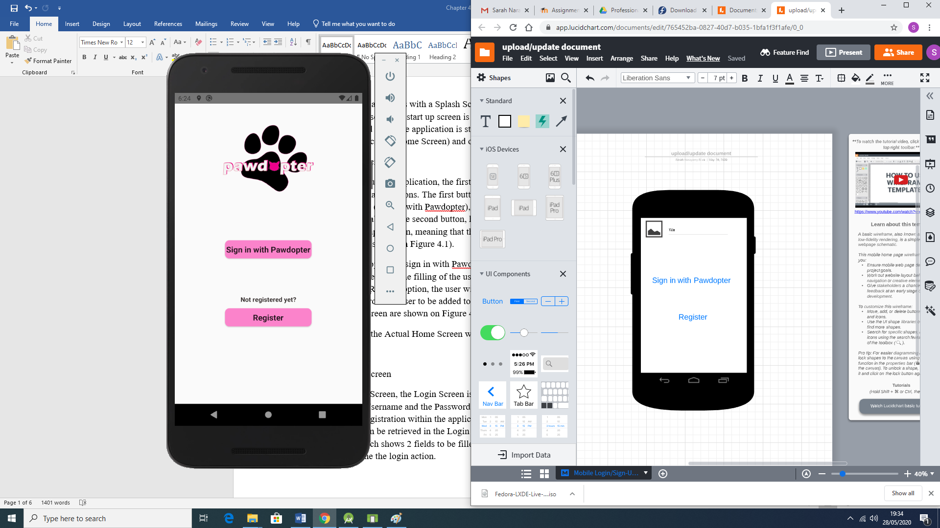

When clicked on the option to sign in with Pawdopter, the potential adopter is redirected to a Login Screen which requires the filling of the username and the password already registered. When clicked on the Register option, the user will be redirected to a Register Screen which will collect the data from the user to be added to the database. Snippets of Java and XML code for the Home Screen are shown on Figure 4.2 and Figure 4.3 respectively.

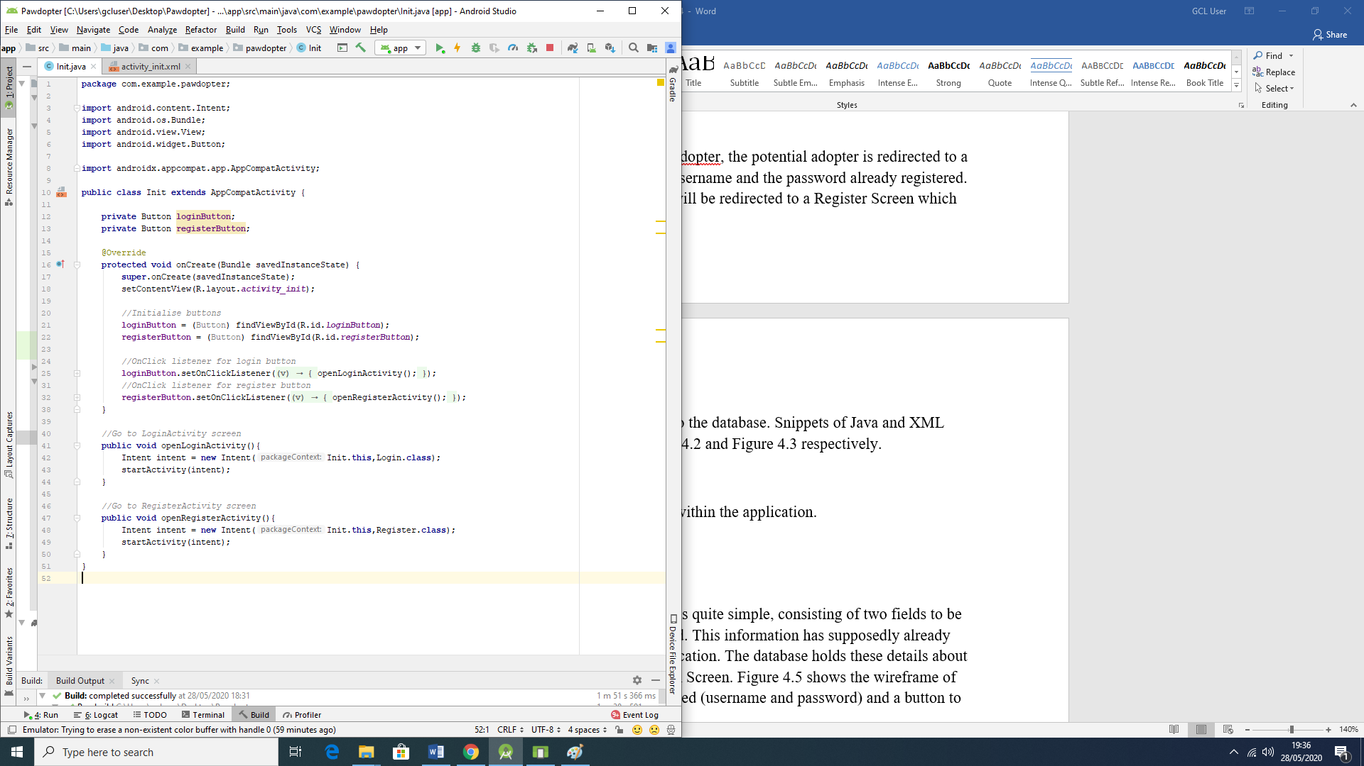 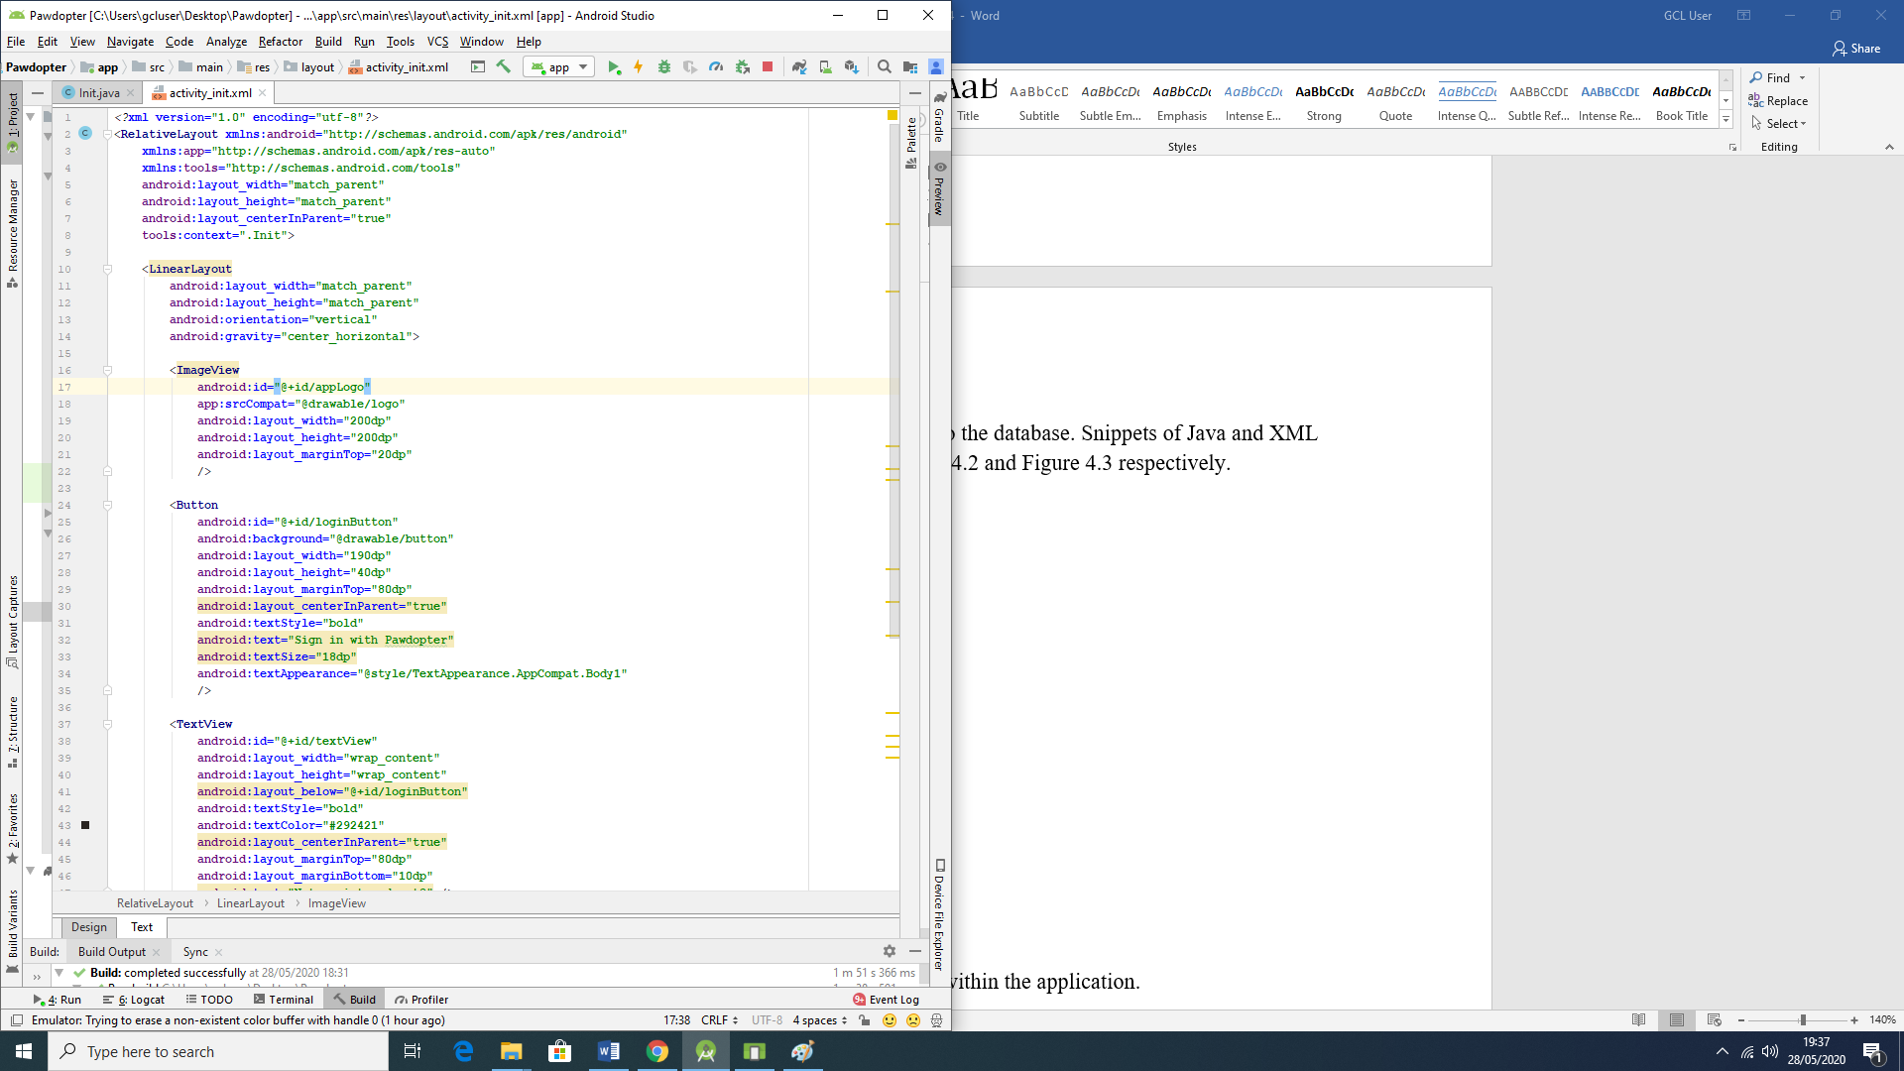

Figure 4.4 represents the Actual Home Screen within the application.

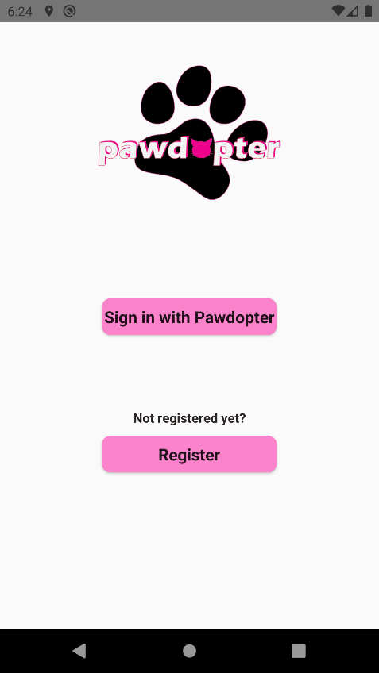

The wireframe and the actual screen differ on where the title and logo of the app should be. In the wireframe the logo is set to be at the top left corner of the screen and the title right beside it, as a pattern for all screens. However, due to aesthetics reasons we decided to place the logo which already contains the name/title of the app aligned on the top centre of the screen.

4.2 Screen 2: Login Screen

As well as the Home Screen, the Login Screen is quite simple, consisting of two fields to be filled which are the Username and the Password. This information has supposedly already been given in prior registration within the application. The database holds these details about each user and they can be retrieved in the Login Screen. Figure 4.5 shows the wireframe of the Login Screen which shows 2 fields to be filled (username and password) and a button to be clicked and resume the login action.

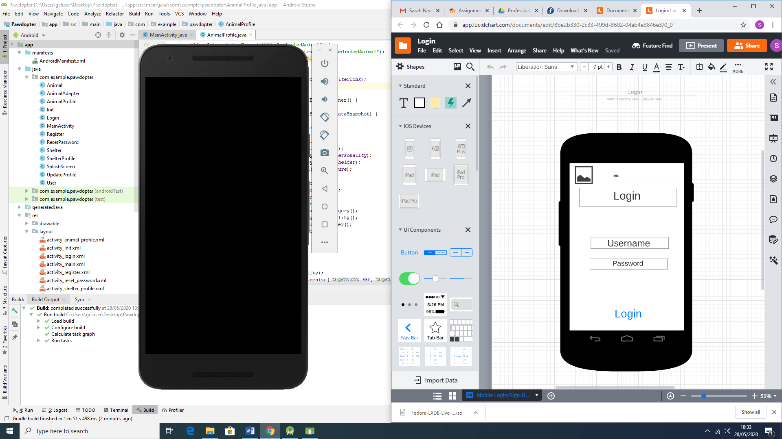

Figure 4.6 and Figure 4.7 shows snippets of Java and XML code respectively for this screen.

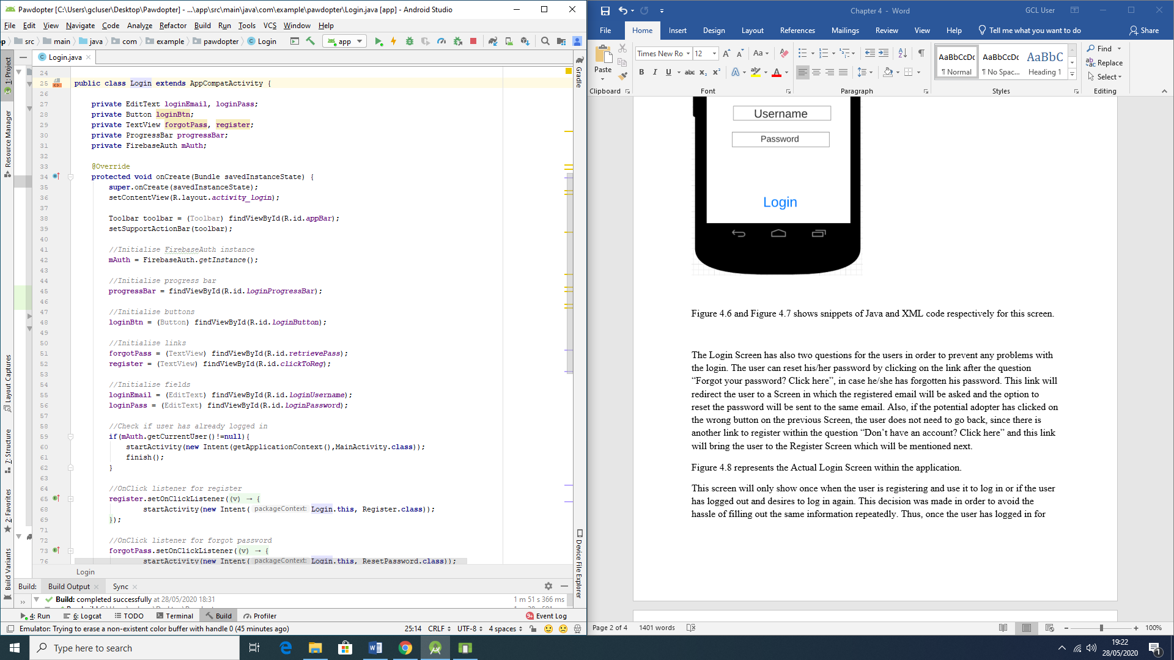 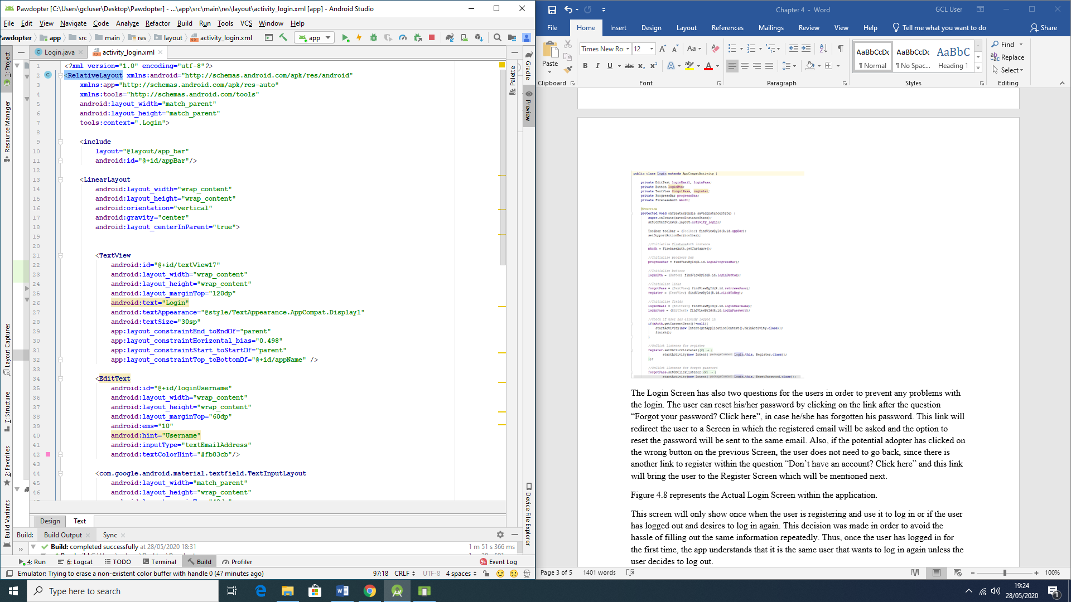

The Login Screen has also two questions for the users in order to prevent any problems with the login. The user can reset his/her password by clicking on the link after the question “Forgot your password? Click here”, in case he/she has forgotten his/her password. This link will redirect the user to a Screen in which the registered email will be asked and the option to reset the password will be sent to the same email. Also, if the potential adopter has clicked on the wrong button on the previous Screen, the user does not need to go back, since there is another link to register within the question “Don’t have an account? Click here” and this link will bring the user to the Register Screen which will be mentioned next.

Figure 4.8 represents the Actual Login Screen within the application.

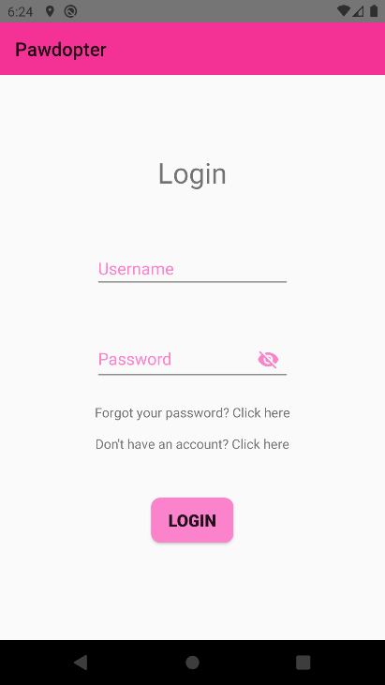

This screen will only show if the user has logged out and desires to log in again or if the user is not logged in yet. This decision was made in order to avoid the hassle of filling out the same information repeatedly. Thus, once the user has logged in for the first time, the app understands that it is the same user that wants to log in again and directs the user to the Pet visualisation and filtering Screen that is described on topic 4.4.

The wireframe and the actual screen also differ on where the title and logo of the app should be. In the wireframe the logo is set to be at the top left corner of the screen and the title right beside it. However, due to aesthetics reasons we decided to display only the title of app on the top left corner. There are also, the addition of the links in case of forgotten password and to register without having to go back a screen.

4.3 Screen 3: Registration Screen

The Registration Screen is very important because it will collect the data from the potential adopter and this data will be saved within the application database which is performed by Firebase. The information collected in this screen consists firstly of Name, which is important in order to deal with the user in a directed and respectful way, by using their name, for example, “Welcome Sarah”; secondly the Phone Number, which is important in order to contact the user, if necessary; thirdly the Email is very important, which could also be used to contact the user but most importantly to determine the Username, once email is unique for each person; fourthly the password chosen by the user, which should contain at least one lower case, at least one upper case, at least one number, at least one special character and 8 characters long; fifthly the user is asked to re-enter the password already entered in the previous field, this field is important because it allows the user and the database to verify the veracity of such passwords.

The screen has a submit button which has to be clicked after all the fields are filled by the user. It is important to state that all the fields are mandatory, which means that the user will not be able to register if one or more fields are blank. There are also different criteria for the fields in order to validate the information, such as mobile number, which should start with “08” in order to be valid as an Irish number and should be 10 digit long. The email should contain the username, the @ symbol and the domain.

Figure 4.9 illustrates the wireframe which consists of the fields to be field for the registration screen and the submit button as well as snippets of Java and XML code on Figure 4.10 and Figure 4.11 respectively.

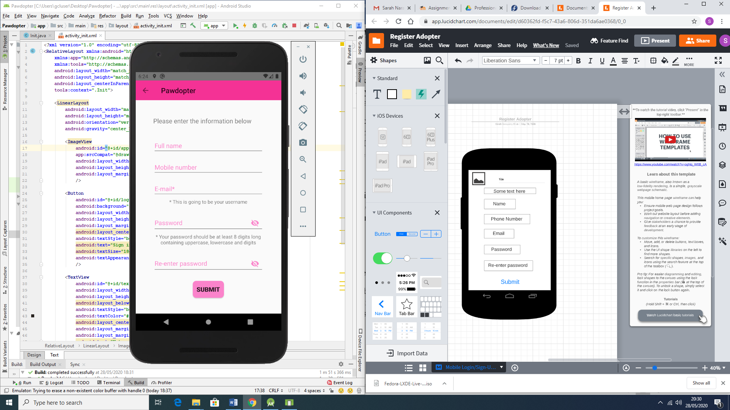

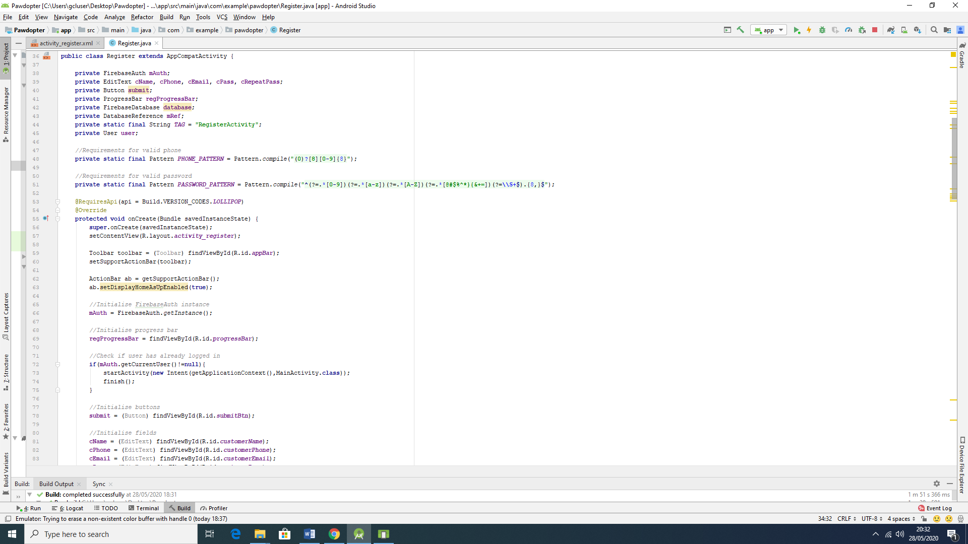 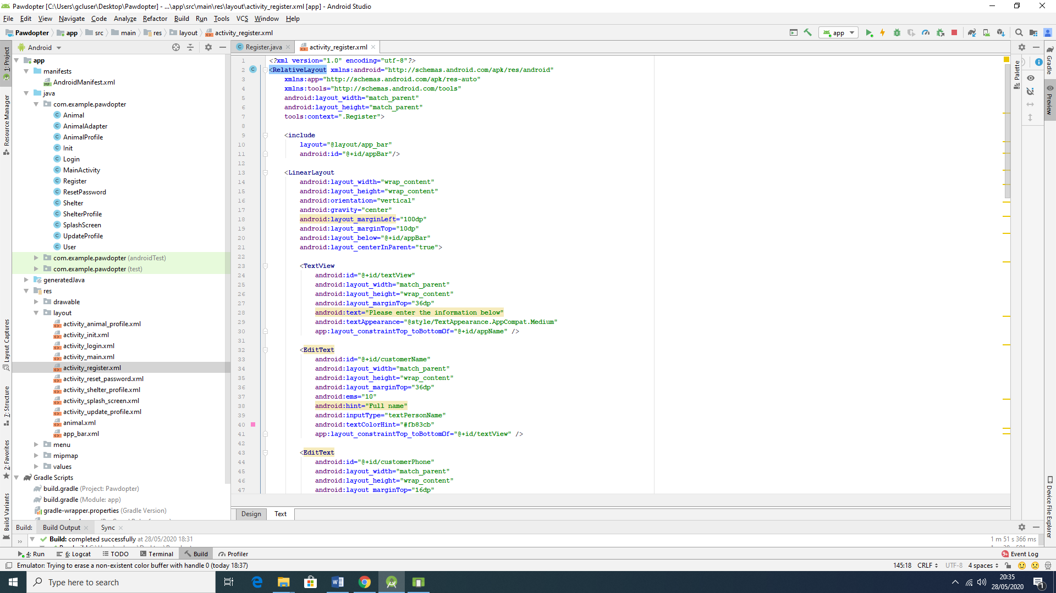

Figure 4.12 shows the actual Registration Screen within the application.

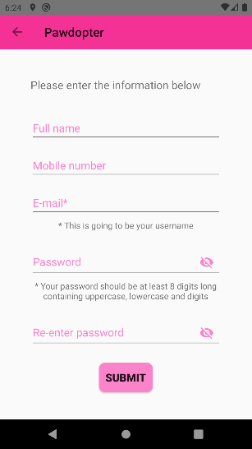

The wireframe and the actual screen differ on the same aspects mentioned before related to the logo and name of the application. In this screen, the logo is replaced with an arrow directed to the left which implies that the user can go back to the previous screen, followed by the title of the app.

4.4 Screen 4: Pet visualisation and filtering Screen

On this screen, the user is able to visualise all the available pets for adoption as well as make use of the filters to search for a pet with specific characteristics. The visualisation of each animal consists of one photograph, its name, its age and its personality. Each animal entry is clickable and once it is done more information about the particular pet will be shown in another screen designed specifically to show only one pet and all its information.

The animals can be filtered firstly by its category, meaning choosing what type of animal is desired (dog, cat, etc); followed by its size, which could be either small, medium or large animal; and lastly by its breed, which will be shown according to the database. It is important to emphasize that these filters are nested and dependent on each other. Once the filtering is done by the user, the visualization screen will only show the pets that correspond to the characteristics specified by the user.

Another important aspect of this screen, is that it provides a menu for the user to update its profile or to logout.

Figure 4.13 illustrates the wireframe for the Pet visualisation and filtering screen as well as snippets of Java and XML code on Figure 4.14 and Figure 4.15 respectively. Figure 4.16 shows the actual Registration Screen within the application.

4.5 Screen 5: User update profile Screen

This screen provides a screen similar to registration screen in which the user can update its information. However, a few information can not be changed such as name and email, once they are unique to each person. Thus, in this screen the user is allowed to change the contact number and the password according to the specifications for each field as mentioned before on the registration screen. Once the save button is clicked, all the information changed is real time updated in the database.

Figure 4.17 illustrates the wireframe for the User update profile Screen as well as snippets of Java and XML code on Figure 4.18 and Figure 4.19 respectively. Figure 4.20 shows the actual Registration Screen within the application. Figure 4.21 and 4.22 shows before and after the information is changed in database respectively.

4.6 Screen 6: Individual pet visualization Screen

When the user clicks on a desired pet in the Pet visualisation and filtering Screen, the user is redirect to this individual pet visualization screen that provides all the remaining information about the animal. This information are as follows: picture, name, breed, age, gender, personality and the shelter in which this animal is kept.